**Implementation of Incremental Sheet Forming on Commercial Pure Titanium Sheet**

**Aastha Pande and Shivprakash Barve**

School of Mechanical Engineering, Dr. Vishwanath Karad MIT World Peace University, Pune, Maharashtra 411038, India

**Abstract:**

Single Point Incremental Forming (SPIF) is a sheet metal forming process that has gained popularity due to its ability to produce complex geometries with a single point tool. The SPIF process is adaptable, affordable, quick, and better suited for prototype and small-batch manufacturing. The method without the use of a die, using a CNC milling machine. In order to comprehend the process of incremental sheet formation, this work documented the experimental methodology and the impact of various process parameters on Commercially Pure Titanium Grade 4 (CpTi). SPIF for CpTi has demonstrated encouraging results in the creation of complicated forms. However, there are difficulties like fractures, thickness difference, and spring back. For SPIF to perform better overall for CpTi, process parameters must be optimised.

**Keywords:** Incremental Sheet Forming, Metal forming, Commercially Pure Titanium

**1.Introduction**

Prototype and small batch production is cheap and fast by SPIF as compared to traditional forming process. SPIF is a sheet metal forming process that has gained popularity due to its ability to produce complex geometries with a single point tool. SPIF involves clamping a sheet metal blank to a fixture and incrementally deforming it using a rotating tool, which is fed into the sheet metal at a specific location. ISF is flexible, cheap and required less lead time [1, 2]. The process is carried out on a CNC milling machine without the use of die. localised deformation is carried out by hemispherical tool progressive in ISF [3, 4]. The principal concept of ISF is to generate required shape progressively by enabling localized deformation using form tool as shown in Fig. 1 [5]. SPIF has been used in a variety of applications, including the production of automobile panels, aircraft parts, and medical implants. In the automotive industry, SPIF has been used to produce complex shapes for fenders, hoods, and doors. In the aerospace industry, SPIF has been used to produce components for aircraft wings and fuselages. In the medical industry, SPIF has been used to produce custom implants for patients, such as cranial plates and jawbone replacements [6].

|  |
| --- |
|  |

*Corresponding author: Shivprakash B. Barve, Tel.;

E-mail address: [shivprakash.barve@mitwpu.edu.in](mailto:shivprakash.barve@mitwpu.edu.in)

ISF's top priority is geometric precision. Geometric precision depends on a number of factors, including tool diameter, step size, speed, feed, and lubrication. One of the determining factors for geometric correctness is tool path. Numerous studies investigated parameter optimisation to reduce production time and produced sheet thickness dispersion [7]. Key challenges of SPIF are geometric accuracy, optimization of process mechanics and defect free (spring back, wrinkling or tearing) forming.

Researchers were performed experiments with different approaches to optimize process parameters on sheet formability. The formability of sheet is significantly influenced by the type of material. on explore formability, the ISF technique was used on commercially pure titanium sheet. Increases in feed rate and tool size were found to negatively impact sheet formability [8–10].

A study by Muftooh Ur Rehman Siddiqi (2016) scrutinized that single point incremental process has impact on the behaviour and mechanical properties of pure titanium grade 4 (CP-Ti) This understanding was developed by tensile testing and numerical modeling of specimens from CpTi

Titanium has paid attention of researchers for its properties such as light weight, good specific strength and anti-rust. Titanium grade 4 has strength like stainless steel and accepted by industries for corrosion resistant applications in the chemical, aeronautical and biomedical industries. Conventional sheet forming processes used for titanium sheets are stretch, power, rubber pad and roll forming [11, 12]. Formability is improved at elevated

In light of literature review it tends to be reasoned that SPIF using Pure Titanium Grade 4 is a challenging process that requires careful selection and optimization of process parameters, tool design, and machine setup

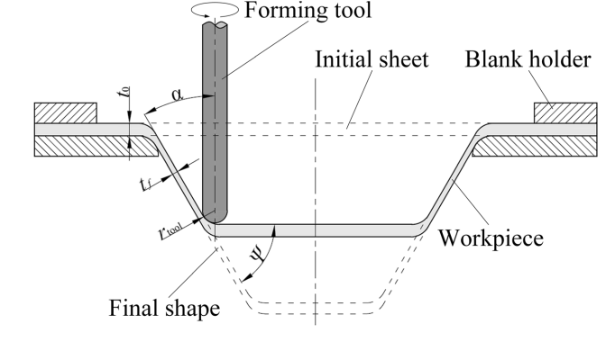

**Fig. 1: Principle of SPIF [5]**

temperatures in these processes [13]. Forming processes are cost effective and improves mechanical properties at room temperature. Number of forming processes were developed by researchers and SPIF has paid more attention in the last decade [14]. SPIF could produce complex shapes with high accuracy using pure titanium sheets with a thickness 0.5 to 1.5 mm. Another study scrutinized that ISF and forming parameters has impact on the behaviour and mechanical properties of pure titanium grade 4 (CP-Ti) This understanding was developed by tensile testing and numerical modeling of specimens from CpTi [15, 16].

The deformation induced by the SPIF process also results in a significant grain refinement in the Ti-4 material, leading to improved mechanical properties. Further research is required to optimize the process parameters for explicit applications and to examine the impact of SPIF on the microstructure and mechanical properties of Ti-4 sections in more detailTop of Form

**2. Methodology**

ISF is a developing technique and there is need to understand internal mechanics and microstructure during the process. This article reported experimental studies to understand ISF process for CpTi.

Following steps to be followed to process CpTi using ISF, The following is a suggested methodology for performing Single Point Incremental Forming (SPIF) using Pure Titanium Grade 4

* Selection of material.
* Select the area of sheets and cut sheets accordingly.
* Design the fixture to clamp the sheet in the fixture.
* Select CNC milling machine
* Select tool material
* Design hemispherical tool
* Generate optimum tool path using software (Fusion 360 / MATLAB)
* Set process parameters of CNC milling machine.
* Process CpTi sheets using ISF
* 3D scan to measure spring back and variation in thickness.
* Observe microstructure changes and factography by Scanning Electron Microscope.
* Compare the quality of formed sheets with software results.

This methodology provides a general framework for performing SPIF using Pure Titanium Grade 4. t is important to carefully select the process parameters and tool path to ensure that the formed part meets the required formability and surface quality criteria. Proper quality control and post-processing are also important steps to ensure that the final product meets the required specifications.,

**3. Modelling and Analysis**

Using the finite element approach, the deformation of the CP-Ti Gr. 4 sheet during the ISF process was calculated. Table 1 displays the mechanical characteristics of CP-Ti Gr. 4 pure titanium

**Table 1: Mechanical properties of CP-Ti Gr.4 [13]**

|  |  |  |  |  |  |
| --- | --- | --- | --- | --- | --- |
| **Tensile stress**  **(MPa)** | **Yield stress (MPa)** | **Young’s modulus (MPa)** | **Poisson’s ratio** | **Density (g/cm3 )** | **Elongation**  **(%)** |
| 680 | 560 | 105,000 | 0.34 – 0.4 | 4.510 | 23 |

To obtain an explicit solution in the ISF, ABAQUS Explicit software was used. As the blank holder and backing plate, a square of 100 mm × 100 mm titanium sheet was used, sandwiched between two similar denture foundation plates. To cause the sheet to gradually deform, the tool path was constructed. A FE model was utilised to simulate a blank sheet utilising a quadrilateral shell element with four nodes, six degrees of freedom per node, and seven Gaussian reduced integration points across the thickness direction. With 14400 elements and 14641 nodes, the mesh has a 1mm square. Fig. 2 depicts a schematic of the FEA simulation setup, tool location, and meshing configuration. Using a tool in ISF, the sheet was distorted successively in tiny steps [17].

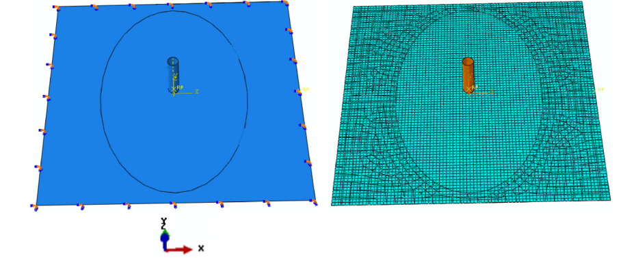

Fig. 2: Schematic of the setup in FEA simulation and tool position and meshing configuration [17]

Using Design of Experiments (DOE), the impact of manufacturing process factors was managed to make it cost-effective. The number of tests and materials used decreased when DOE was used. The experimental mistakes were reduced by the findings analysis. DOE can be a powerful tool for optimizing the SPIF process parameters for Pure Titanium Grade 4. By systematically varying the factors and measuring the response variable, it is feasible to identify the optimal process parameters that will produce high-quality formed parts. This information can be used to improve the efficiency and effectiveness of the SPIF process for producing Pure Titanium Grade 4 parts with the desired formability, surface quality, and mechanical properties.

**4. Experimental Work**

Titanium has a special mix of mechanical properties that make it a very sought-after material. But titanium grade 4 is notorious for having poor formability, making it difficult to deal with when utilising conventional forming methods. For testing, a Cp Ti sheet with a thickness of 0.99 mm was selected. Table 2 displays the CP-Ti's chemical make-up. The examinations were performed on CPTi sheet with as indicated by standard method The Forming is done by using Hemispherical Head Tool. The fractured specimen is then studied under standard instrument to quantify ouput response parameters..

Table 2: Chemical composition of CP-Ti

|  |  |
| --- | --- |
| **Element** | **Content (%)** |
| Titanium, Ti | 98.955 |
| Iron, Fe | 0.500 |
| Oxygen, O | 0.400 |
| Carbon, C | 0.080 |
| Hydrogen, H | 0.050 |
| Nitrogen, N | 0.015 |

While working with pure titanium grade 4, following few key considerations were ensured for the successful implementation of ISF:

* **Work piece preparation**: The work piece was cleaned and polished to remove any surface contaminants or defects that could impact the accuracy of the process. The sheets in the square shape with a size of 100 mm x 100 mm and placed between two identical denture base plates as blank holder and backing plate [18,19].
* **Tool selection**: The tool used in the process should be made from a material that is compatible with pure titanium grade 4, such as surface hardened HSS tool (60-65 HRC), tungsten carbide or diamond. The tool should also be properly sharpened to ensure precise cutting. The tool had a 12 mm diameter. The shaping tool was moved down with a fixed step size and rotated around a virtual axis in radial increments.
* **Lubrication:** Pure titanium grade 4 has a tendency to stick to cutting tools, so it is important to use a suitable lubricant to reduce friction and improve cutting efficiency. The organic lubricants were squeezed by a strong contact force between the tool tip and the sheet. An inorganic lubricants mixed with grease was recommended. MoS2 powder and petroleum jelly were combined to make a paste, which was applied to the oxide film in a 4:1 ratio to lubricate it [20].
* **Pitch:** The range of the pitch ranged from 0.2 to 1.3 mm. The value of angle varies from 600 to 650. It was found that when the pitch value increased, the sheet was undergoing partial pulling and partly forming deformation, producing surface roughness.
* **Feed Rate:** As the feed rate increased formability of sheet was decreased. The formability was good when feed rate was in the range of 1200 mm/min to 2600 mm/min.
* **Tool Diameter:** The formability was maximum **65.6°**, when tool diameter was 16 mm and it decreased to **63.1°** when tool diameter was 8 mm. As tool diameter increased the contact area increased and The contact area grew as tool diameter grew, hence deformation did not stay localised.
* **Step Depth ;**- The step depth should be selected based on several factors, including the sheet thickness, tool geometry, machine capabilities, and desired properties of the formed part. A lower step depth can improve formability and reduce the likelihood of cracking, but may result in longer cycle times. A higher step depth can increase the forming depth and reduce cycle times, but may also increase the likelihood of surface defects and reduce the accuracy of the formed part.
* **Optimization of process parameters**: To increase the formability of the titanium sheet and produce the necessary component geometry, process variables such tool diameter, feed rate, and spindle speed were optimised. [23].
* **Fixture:** The fixture was fixed on the force dynamometer as shown in Fig. 3.
* **Experimental set up:** Experimental set up of CNC milling is shown in Fig. 4.
* **Forming process:** The forming process involves clamping the titanium sheet onto a fixture and positioning the hemispherical tool above the sheet. The tool was lowered onto the sheet and moved in a circular motion while applying a downward force. This caused the sheet to deform gradually, forming the desired shape.
* **Forming sequence:** The incremental forming process was carried out until the desired final part geometry was achieved. It required multiple passes with the forming tool over different areas of the sheet metal.
* **Formability evaluation:** The formability of the titanium sheet was evaluated by examining the formed part for defects such as wrinkling, tearing, or fracture. In addition, the strain distribution and thickness variation across the formed part was analysed using strain gauges and optical measurement techniques.
* **Finishing**: Once the final part geometry was achieved, the part required additional finishing operations, such as deburring or polishing.
* **Evaluation**: The final parts were evaluated for accuracy and surface finish.

Overall, SPIF process is a versatile and cost-effective method for producing complex and customized parts from pure titanium grade 4. However, the process requires careful selection of material and process parameters to ensure good formability and quality of the formed parts.

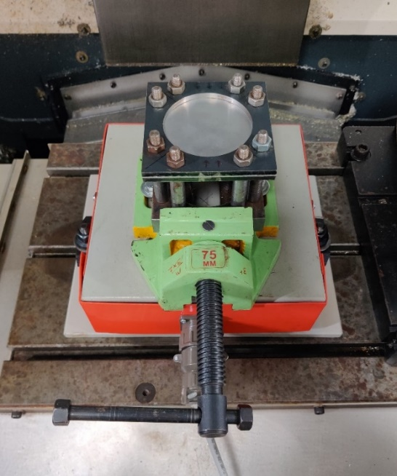

Fig. 3: Fixture with force dynamometer for ISF

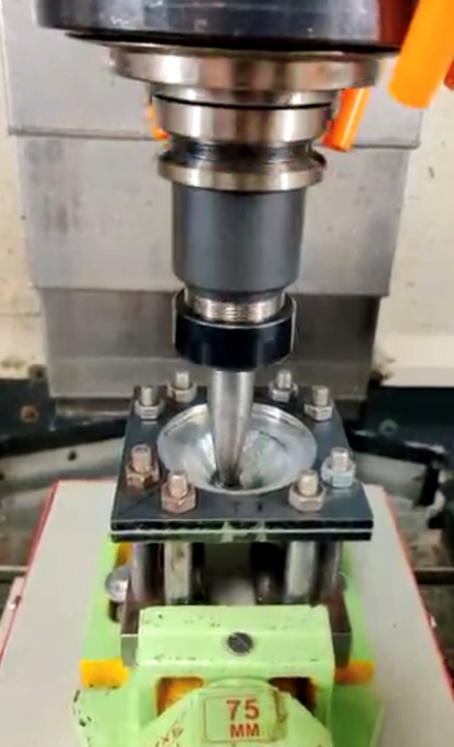

**Fig. 4: Experimental set up**

**5. Conclusion**

ISF process and effect of process parameters on formability was titanium grade 4 sheets was studied and important points are summarised as follows,

* ISF was successfully implemented to form titanium grade 4 sheets with relatively small wall angles.
* The quality of the produced item is substantially influenced by process variables including step depth, feed rate, and spindle speed, which must be optimised to provide the correct geometry and surface polish.
* The tool with larger contact area distributed deformation more evenly and reduced the spring back.
* The use of lubricants during the forming process had improved the surface quality and reduced the occurrence of defects such as cracks and wrinkles.
* The strain rate and direction of the forming process had an influence on the mechanical characteristics of the produced sheet.
* The final geometry of the produced item was significantly influenced by the initial sheet material's thickness, and thinner sheet was often favoured for more intricate geometries.
* The combined impact of tool diameter (d) and pitch (p) on formability has to be studied.

**References**

[1]. Thibaud, Sébastien, et al. "A fully parametric toolbox for the simulation of single point incremental sheet forming process: Numerical feasibility and experimental validation." *Simulation Modelling Practice and Theory* 29 (2012): 32-43.

[2]. Khare, Unmesh, and Martand Pandagale. "A review of fundamentals and advancement in incremental sheet metal forming." *IOSR Journal of Mechanical and Civil Engineering* 8 (2014): 42-46.

[3]. Liu, Zhaobing, et al. "Modeling and optimization of surface roughness in incremental sheet forming using a multi-objective function." *Materials and Manufacturing Processes* 29.7 (2014): 808-818.

[4]. Sieczkarek, P., et al. "Wear behavior of tribologically optimized tool surfaces for incremental forming processes." *Tribology International* 104 (2016): 64-72.

[5] Echrif, S. B. M., and Meftah Hrairi. "Research and progress in incremental sheet forming processes." *Materials and Manufacturing Processes* 26.11 (2011): 1404-1414.

[6]. Durante, M., et al. "The influence of tool rotation on an incremental forming process." *Journal of Materials Processing Technology* 209.9 (2009): 4621-4626.

[7]. Selvarajan, L., C. Sathiya Narayanan, and R. JeyaPaul. "Optimization of EDM parameters on machining Si3N4–TiN composite for improving circularity, cylindricity, and perpendicularity." *Materials and Manufacturing Processes* 31.4 (2016): 405-412.

[8]. Hussain, G., L. Gao, and Z. Y. Zhang. "Formability evaluation of a pure titanium sheet in the cold incremental forming process." *The International Journal of Advanced Manufacturing Technology* 37 (2008): 920-926.

[9] Myers, J. R., H. B. Bomberger, and F. H. Froes. "Corrosion behavior and use of titanium and its alloys." *JOM* 36.10 (1984): 50-60.

[10] Chen, Fuh-Kuo, and Kuan-Hua Chiu. "Stamping formability of pure titanium sheets." *Journal of materials processing technology* 170.1-2 (2005): 181-186.

[11] Matsubara, Shigeo. "Incremental backward bulge forming of a sheet metal with a hemispherical head tool." *J. Jpn. Soc. Tech. Plasticity* 35.406 (1994): 1311.

[12] Kopac, J., and Z. Kampus. "Incremental sheet metal forming on CNC milling machine-tool." *Journal of materials processing technology* 162 (2005): 622-628.

[13] Lu, B., et al. "Titanium based cranial reconstruction using incremental sheet forming." *International Journal of Material Forming* 9 (2016): 361-370.

[14] Kempthorne, Oscar. "The design and analysis of experiments." (1952).

[15] Siddiqi, Muftooh Ur Rehman, et al. "Design and validation of a fixture for positive incremental sheet forming." *Proceedings of the Institution of Mechanical Engineers, Part B: Journal of Engineering Manufacture* 232.4 (2018): 629-643.

[16] Gurav, Hemant, et al. "Multi objective optimization of incremental forming process on commercially pure titanium sheet by using Taguchi-grey and regression." *IOSR J Eng* 10 (2020): 71-81.

[17] Sbayti, M., et al. "Optimization techniques applied to single point incremental forming process for biomedical application." *The International Journal of Advanced Manufacturing Technology* 95 (2018): 1789-1804.

[18] Kharche, Aditya, and Shivprakash Barve. "Experimental investigations of machining parameters on polyamide 6 using single point incremental forming." *Materials Today: Proceedings*, (2022).

[19] Kharche, Aditya, and Shivprakash Barve. "Incremental sheet forming of composite material." *Materials Today: Proceedings*, (2022), Volume 63, pp 176-184

[20] Shi, Xiaofan, et al. "Electric hot incremental forming of low carbon steel sheet: accuracy improvement." *The International Journal of Advanced Manufacturing Technology* 68 (2013): 241-247.